**Crestron Certified Integrated Partner Module: Load Preset v2.0**

**Models:** Symetrix Integrator Series; 722, 760, 761, 780, 788. Jupiter Series; J4, J8, J12. SymNet; 8x8 DSP, Express Cobra DSP, Solus DSP, Edge DSP, Radius DSP.

**Device Type:** Audio Mixer, DSP.

**General Information**

The Certified Crestron Module SymNet Load Preset v2.0 is used to recall a preset within any Symetrix DSP device. It produces an LP # command which is recognized by the SymNet DSP's 3rd Party Control Protocol as a Load Preset command. This module is a SIMPL + file and should be added saved and compiled in your Crestron project folder, or SIMPL User + directory and brought into your project file.

**Category:** Mixer, Audio DSP.

**Version:** 2.0

**Summary:**

This Load preset module simply accepts the preset number from the integrator and transmits LP #. The number that is put into the module is the number of the SymNet Preset. It acts as a momentary button and each button press will send the command out once.

**General Notes:**

This module is different from the Load Preset v1.0 that is available in that it uses the LP command and not the LPG (Load Preset Global) command that the v1.0 modules used. The "G" in the LPG command referred to Globally recalling the preset across a SymLink ring, or across a Cobranet network. The Edge and Radius product, those DSP which are programmed by SymNet Composer, use Dante to transmit and receive digital audio and control. SymLink and Cobranet are not being used in Edge and Radius. Thus, the idea of the SymLink Ring and Cobranet connection has gone away. The Edge and Radius will not respond to the LPG command which comes from the v1.0 Load Preset module. The [Legacy SymNet Crestron Integrated Partner Modules](http://www.symetrix.co/product_faq/are-crestron-modules-available-for-symnet-2/), can be found by clicking on the previous hyperlink.

**Crestron Hardware Required:**

2 or 3 Series. RS-232, or UDP card required.

**Setup of Crestron Hardware:**

*RS-232.* Baud Rate; 38400 to 115200 - Configurable through SymNet Software Application. 8 Bit, Non-Parity, Stop Bit; 1, Flow Control; None.

*Crestron Cable Type.* CNSP-121

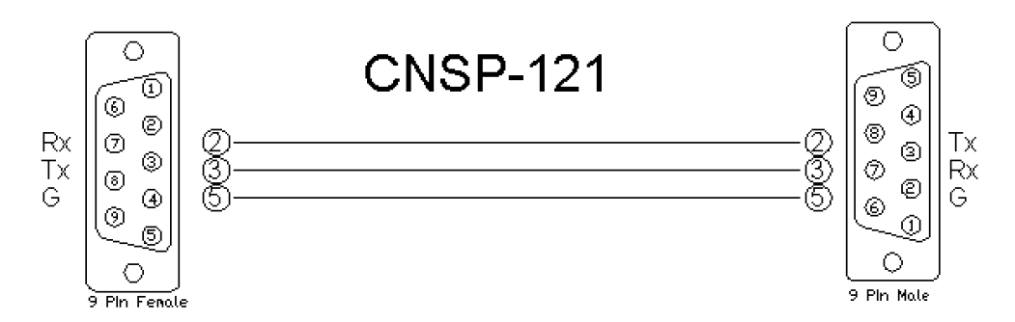

*UDP/IP.* Port: 48630.

**Application Notes:**

This Load Preset v2 module is compatible with all SymNet Software and unit Firmware versions. Those DSP which are programmed with SymNet Designer; 8x8 DSP, Express Cobra, Solus units, used the Legacy architecture of Numbered Rings and Unit Address Numbers within those rings. Those DSP which are programmed with SymNet Composer; Edge and Radius, use Dante to transmit digital audio and control between units. The Edge and Radius DSP will not respond to the Version 1 Crestron Integrated Partner Modules. Use the Version 2 modules when working with Edge and Radius DSP. These units will only respond to the LP Load Preset command used in the Version 2 modules. They do not respond to the LPG Load Preset Global command. This is due to the fact that the concept of the SymLink ring has gone away.

The integrator first needs to devise the preset within the SymNet DSP. Make sure to note whether you are creating a global vs. a custom preset. Once the preset is stored the integrator will enter the number of the preset into the control field labeled Preset_Number. A variable should be devised to come from the press of the touch-panel and a reference name should be entered.

A Load Preset v2.0 module should be placed in the design from the SIMPL + Project Modules directory for every preset that needs to be recalled. It is likely that v2.1 will bring with it a GPR (Get Preset) command to show which preset is currently loaded as well as the ability to expand the module so that only one SymNet Load Preset module needs to be brought into the Crestron project file. Please standby for future releases and updates.

**Module Graphic:**

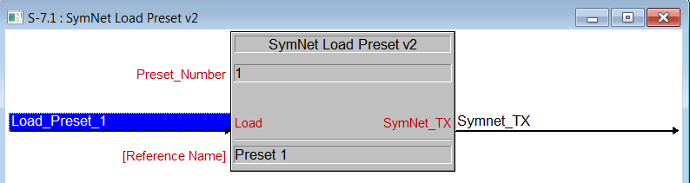

**Control:**

*Load.* Signal Type: Digital. This is the location where the integrator will place the variable which relates to the press in the touch-panel module. This is the variable coming from the touch-panel which will cue the preset load.

*Symnet_TX.* Signal Type: Serial. This is the serial string transmission from the Crestron module(s)/project into the SymNet DSP.

**Parameters:**

*Preset_Number.* Signal Type: Variable to be entered by the Integrator. Enter a digit into this Parameter field that is the number of the preset to be loaded.

**Feedback:**

*N/A.* There is not any feedback necessarily coming from the SymNet device into this module. In order to have the buttons actually appear to engage on the touch panel, put the same variable that is the button press into the feedback portion of the touch-panel module in SIMPL. This will give the buttons the appearance of going into their active state for the moment when pressed.

**Testing:**

*SymNet OS.* SymNet Designer v10.06, SymNet Composer v1.1, Jupiter Software v2.0.1.12, Integrator Series 761 Software v2.01. *SIMPL OS.* 4.01 *Crestron DB.* 35.00.004.00